Course Administrator (CA) Instructions

# CA Screens:

Dashboard Screen

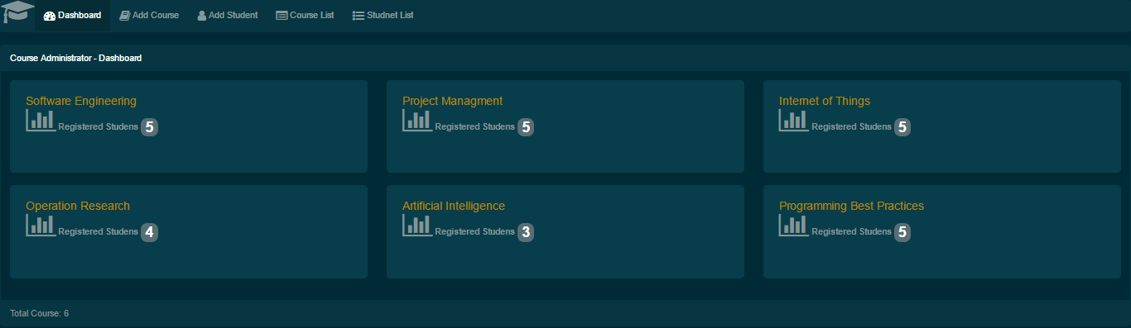

Add Course Screen

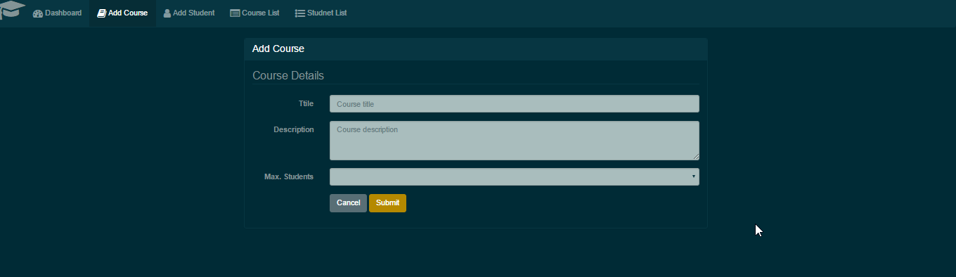

Add Student Screen

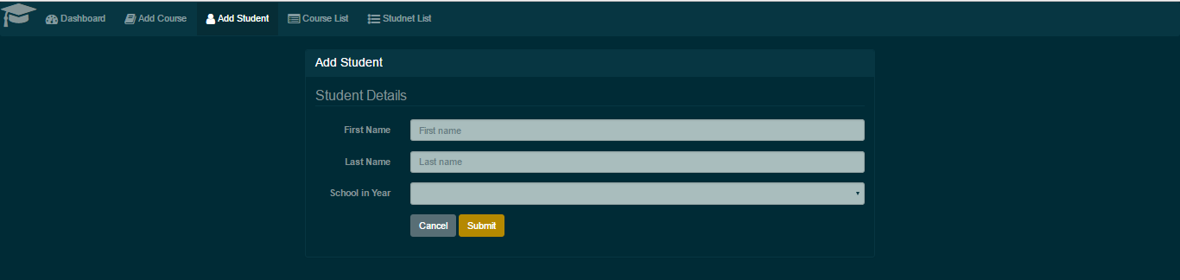

Course List Screen

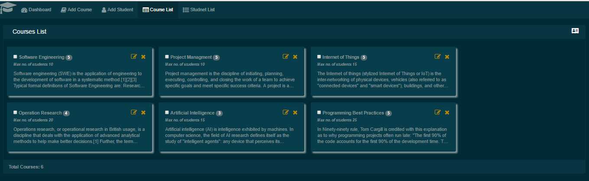

Student List Screen

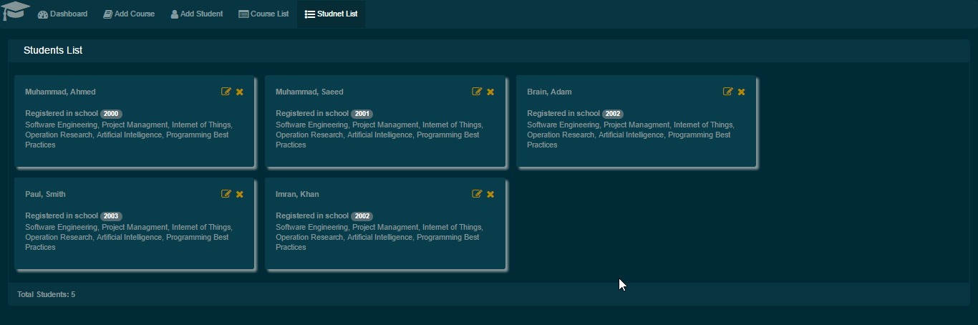

Course Assignment Screen

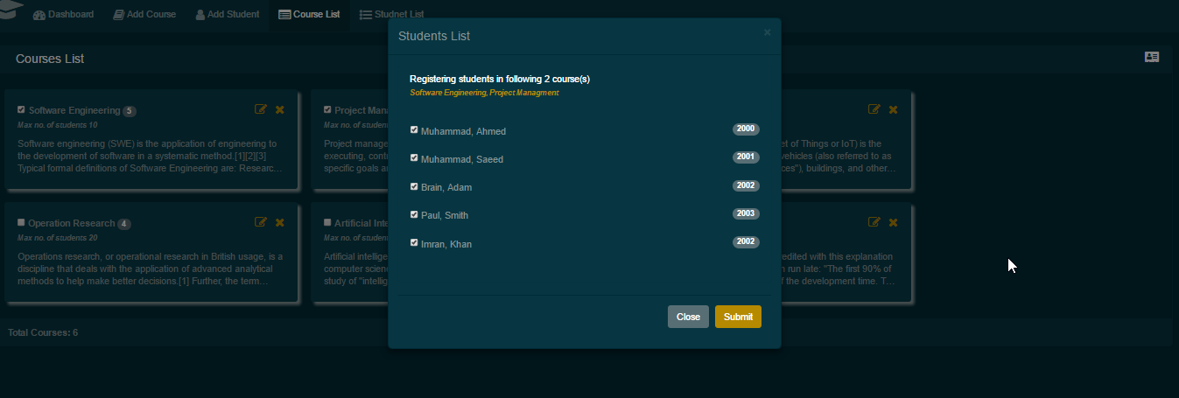

Edit Course & Remove Registered Students Screen

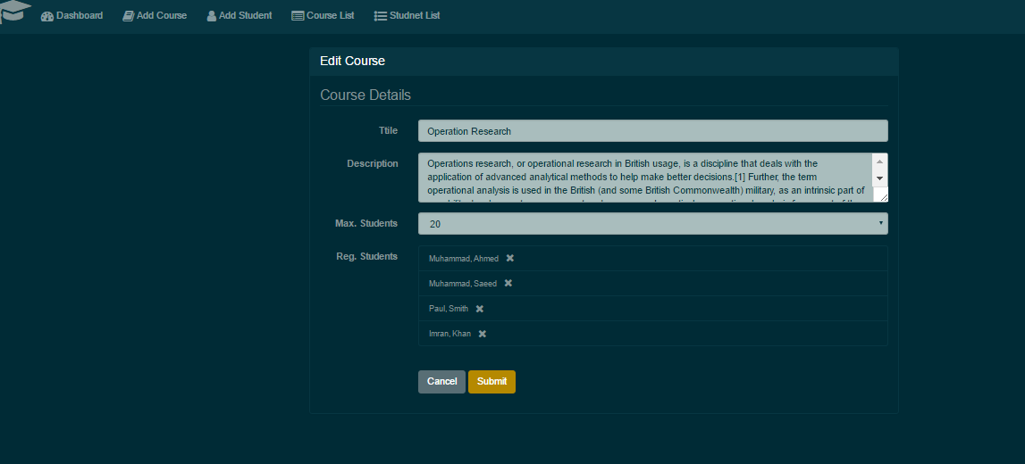

Edit Student & Remove Registered Courses Screen

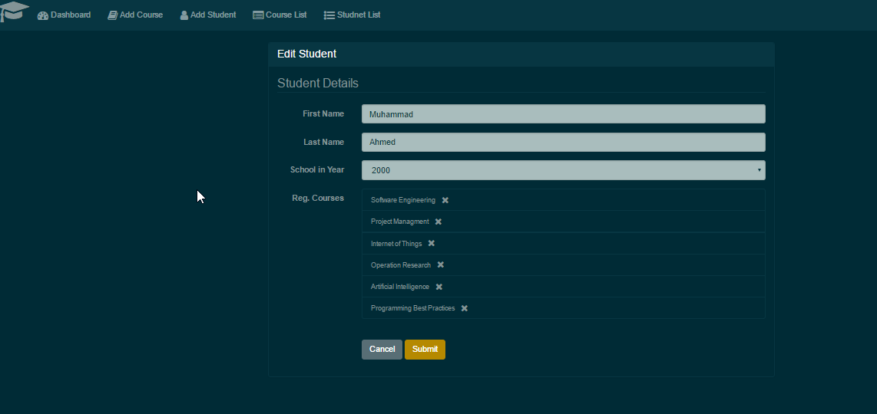

Move Student(s) from One Course to Multiple Course(s) Screen:

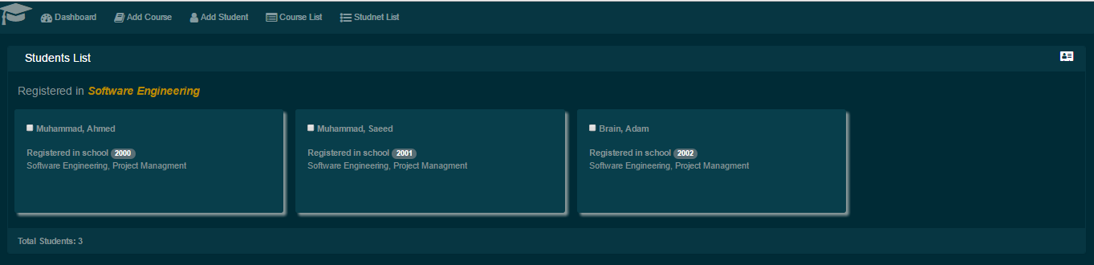

# 

# Add Course:

* Click Add Course Menu.
* Fill title, description and Max. Students fields and press submit to save the changes.
* After clicking submit, user will be redirected to the Course list page where newly added course can be seen.

# Edit Course:

* Go in Course List menu.
* Click "Edit Course" icon at the top second right of specific course to edit it.
* An edit course screen will be open.
* Do the modification and press Submit to save the changes.

# Remove Registered Student From the Course:

* Go in Course List menu.
* Click "Edit Course" icon at the top second right of specific course to edit it.
* An edit course screen will be open.
* The list of all registered students will appear, with remove icon. Click remove icon to delete specific student from the course.

# Delete Course:

* Go in Course List menu.
* Click "Remove Course" icon at the top right of specific course to remove it.

# Assign Single/Multiple Course(s) to Single/Multiple Student(s)

* Go in Course List menu.
* Select checkbox against each course which user wants to assign students to.
* Click top right icon at the header("Registered students in selected course(s) ")
* A popup will appear showing all available list of students with selected courses.
* Select checkbox against each student to register them in selected courses.

# Add Student:

* Click Add Student Link.
* Fill out first name, last name & school in year fields and press Submit to save the changes.
* After clicking submit, user will be redirected to the Student list page where newly added studet can be seen.

# Edit Student:

* Click on Student List Menu.
* List of all available students will appear with edit and remove link at the top right corner.
* Click edit link, it will take the user to edit student screen.
* User can modify the details of the courses and save the changes by clicking on submit button.

# Remove Registered Course(s) from Student

* Click on Student List Menu.
* List of all available students will appear with edit and remove link at the top right corner.
* Click edit link, it will take the user to edit student screen.
* User can see the available course list which are registered for the selected student.
* Each course has remove icon attach with, user can click that icon to remove that course from the student registered course list.
* Click submit to save the changes

# Move Student(s) from One Course to Multiple Course(s)

* Click on Course List Menu.
* Click on Registered students link as shown as marked with red cricle:

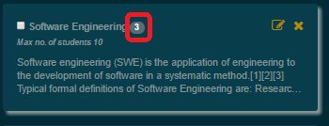

* It will take the user to student list who are registered in that particular course.
* User can select single or multiple students from the list and then click "Move selected student(s) to other course(s)" link at the right most corner of the screen to move students from selected course.
* A new popup screen will appear which display all the available courses other then the current course.
* User can selected single/multiple courses by clicking on the checkbox and press submit button to move selected students to the selected course(s).

